COIS 3400H – Final Project

**Name: Sarah Ann Roy Student ID: 0650615**

# Project Specification:

The objective of my project is to develop an application to maintain databases for students, courses, departments, professors and colleges at Trent University.

The application will be developed using Java and SQL (Structured Query Language) where databases storing information can be manipulated to produce a preferred output using DDL (Data Definition Language) and DML (Data Manipulation Language).

As a student at Trent myself, I became interested in the general processing of applications that maintain the university record. The project will commence with the display of a list of commands the user can choose from. The list would include instructions such as inserting, deleting, retrieving, editing and sorting data in a database about students, courses and colleges.

A college contains many departments such as Computer Science, Forensic Science, Mathematics, Physics, etc. Each department can offer any number of courses. Many instructors can work in a department, but an instructor can work only in one department. For each department, there is a head, and an instructor can be head of only one department. Each instructor can take any number of courses, and a course can be taken by only one instructor. A student can enroll for any number of courses and each course can have any number of students.

Student is an entity, with an identifier, StudentId, created to be the primary key used to distinguish between students, since any two students may have the same Name or DateOfBirth. Department is an entity, with the identifier DepartmentId as the primary key used to distinguish between programs. College is an entity, uniquely identified by CollegeId as the primary key to distinguish between colleges in a university. Professor is an entity, uniquely identified by ProfessorId as the primary key to distinguish between professors.

Each student must be enrolled in a program, so the Student entity participates totally in the many-to-one EnrollsIn relationship with Program. A program can exist without having any enrolled students, so it participates partially in this relationship.

A Course has meaning only in the context of a Program, so Course participates totally in the many-to-one identifying relationship with its owning Program . This means that a Course is uniquely identified using its CourseId and the ProgramId of its owning program. This relationship has Year and Semester attributes that identify its sequence position.

Student and Course are related through the many-to-many Attempts relationships; a course can exist without a student, and a student can be enrolled without attempting any courses, so the participation is not total.

A college must have at least one course directed and a course must be administered in at least one college, so the participation of College and Course is absolute. A College has meaning only in the context of a Course, so College participates totally in the many-to-one identifying relationship with its owning Course .

Although the project is a simple and elementary attempt at the more advanced database design, I hope to gain knowledge about managing and designing databases. For a real university, many more aspects would need to be captured by the database. The database also doesn’t allow a student to be in more than one-degree program, nor does it allow a course to appear as part of different programs.

# List of 10 Queries:

1. What is the percentage in PHYS 1001 at Trent?
2. Who is the Head of Department of the History Department?
3. Which students attending Trent University don’t live in Peterborough?
4. Who were the freshmen students in the year 2018?
5. Which are the half-credit courses in the Computer Science Department?
6. What are the Chemistry courses taught in the university?
7. What are the names of all professors in alphabetical order (A-Z)?
8. What are the courses that commenced before the year 2005?
9. What is the percentage of each course in the Business Administration Department?
10. Display students are born after the year 2000?

# Entities:

* **Student:** A strong entity set for the Students in Trent University.
* **Course:**  Course has meaning only in the context of a Department, so it’s a weak entity, with CourseId as a weak key.
* **College:** A strong entity set containing attributes for all the Colleges in a University campus.
* **Professor:** A strong entity set containing attributes for all the Professors in a Department.
* **Department:** A strong entity set containing attributes for all Departments.

# Attributes:

* **StudentId:** The primary key created to be the primary key used to distinguish between students.
* **StudentName:** A string that holds the first and last name of the student.
* **StudentCity:** Stores the city where the student resides.
* **StudentEmail:** A string that stores the Student Email.
* **DateOfBirth (Student):** A composite attribute which stores the date of birth, composing of the year, month and day.
* **CatalogYear (Student):** An integer that stores the Catalog Year or the freshman year of a Student.
* **CourseId:** An attribute created to be a weak key used to distinguish between Courses.
* **CourseName:** A string that holds the name of the Course.
* **Credits (Course):** A float that stores the Credit points earned with the completion of the Course.
* **Department(Course):**A string that stores the name of the Department to which the course belongs to.
* **Year(Course):** An integer that stores the year of commencement of the Course.
* **ProfessorId:** A unique attribute created to be the primary key used to distinguish between Professors.
* **ProfessorName:** A string that holds the first and last name of a Professor.
* **ProfessorEmail:** A string that stores the Professor email.
* **CollegeId:** A unique attribute created to be the primary key used to distinguish between Colleges.
* **CollegeName:** A string the stores the name of a College.
* **CollegeCity:** A string that stores the name of the city in which the college is located.
* **DepartmentId:** A unique attribute created to be the primary key used to distinguish between Departments.
* **DepartmentName:** A string the stores the name of a College.
* **DepartmentHead:** A string that holds the first and last name of the Head of a Department.
* **DepartmentEmail:** A string that stores the Department email.

# Relationships:

* **EnrollsIn (Student-Course):** Student and Course are related through the many-to-many EnrollsIn relationship; a course can exist without a student, and a student can be enrolled without attempting any courses, so the participation is not total.
* **Advises(Professor-Student):** The many-to-many relationship between the entity sets Student and Professor. A student can be taught by many professors and a professor can advise many students. However, the participation of Student is not total, whereas the participation of Professor is absolute.
* **Administers (College-Course):** A college must have at least one course directed, and a course must be administered in at least one college, so the participation of College and Course is absolute. A College has meaning only in the context of a Course, so College participates totally in the many-to-one identifying relationship with its owning Course.
* **Offers(Department-Course):** The identifying many-to-one relationship between Course and Department. When a student attempts a course, there are attributes to capture the Year and Semester. A Department can have many Courses, but a Course can only belong to one and only one Department. The participation of both Course and Department is absolute in this relationship.
* **Affiliate(Professor-Department):** The many-to-one relationship between Professor and Department implying that a Department can have many Professors working for it, but a Professor can only teach under one and only one Department. The participation of both Professor and Department in the relationship Chairs is absolute.

# Tables:

1. **Student:** Student is table (entity) with six columns (attributes) where StudentId is a primary key which must have a value. StudentName is a varchar and a candidate key. StudentCity is a varchar that stores the city of residence of a student. DateOfBirth is of type DATE and must have a value (NOT NULL). StudentEmail is a varchar of NOT NULL which stores the student email.
2. **Course:** Course is table (entity) with five columns (attributes) where CourseId is a primary key which must have a value. CourseName is a varchar and a candidate key. Department a varchar that stores the department with which the course belongs to. DepartmentId is the unique ID of the Department. DepartmentId is a foreign key that is used in the table Course to get courses under a certain department.
3. **Professor:** Professor is table (entity) with four columns (attributes) where ProfessorId is a primary key which must have a value. ProfessorName is a varchar and a candidate key. ContactNumber is a varchar that stores the phone number of a professor. ProfessorEmail is a varchar of NOT NULL which stores the professor email.
4. **Department:** Department is table (entity) with four columns (attributes) where DepartmentId is a primary key which must have a value. DepartmentName is a varchar and a candidate key. DepartmentHead is a varchar that stores the head of the department. DepartmentEmail is a varchar of NOT NULL which stores the department email.
5. **College:** College is table (entity) with three columns (attributes) where CollegeId is a primary key which must have a value. CollegeName is a varchar and a candidate key. CollegeAddress is a varchar that stores the address of a college.

# Entity-Relationship Diagram:

***For this Lab, the TA gave feedback that many professors cannot chair a single department. I had originally meant for many professors can be affiliated/belong to only one department but only one professor can chair a department.***

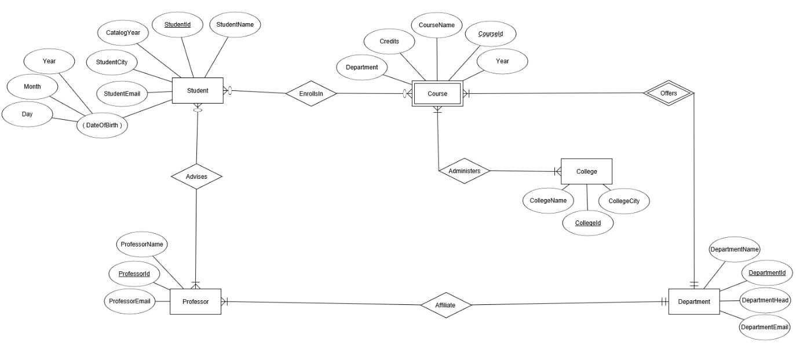

# SQL code:

***For this Lab, the TA gave feedback suggesting that the results from query #10 displays students born before 2000 and not after since I used the wrong mathematical operator. I have done the needed changes and the SQL code is shown below with the 10 queries and results from sqlite3.***

sqlite> .tables

College Course Department Professor Student

sqlite> INSERT INTO Student (StudentId, CatalogYear, StudentCity, DateOfBirth, StudentEmail, StudentName)

VALUES

...> (1010, 2010, ‘Peterborough’, 23-01-1992, ‘[michaelscott@trentu.ca](mailto:michaelscott@trentu.ca)’, ‘Michael Scott’),

...> (1020, 2013, ‘Peterborough’, 20-02-1995, ‘[dwightschrute@trentu.ca](mailto:dwightschrute@trentu.ca)’, ‘Dwight Schrute’),

...> (1030, 2016, ‘Barrie’, ‘1998-03-06’, ‘[jimhalpert@trentu.ca](mailto:jimhalpert@trentu.ca)’, ‘Jim Halpert’),

...> (1040, 2008, ‘Peterborough’, ‘1990-04-17’, ‘[pambeesly@trentu.ca](mailto:pambeesly@trentu.ca)’, ‘Pam Beesly’),

...> (1050, 2019, ‘Vaughn’, ‘2001-05-08’, ‘[ryanhoward@trentu.ca](mailto:ryanhoward@trentu.ca)’, ‘Ryan Howard’),

...> (1060, 2010, ‘Lindsay’, ‘1992-06-16’, ‘[andrewbernard@trentu.ca](mailto:andrewbernard@trentu.ca)’, ‘Andrew Bernard’),

...> (1070, 1975, ‘Oshawa’, ‘1957-07-04’, ‘[stanleyhudson@trentu.ca](mailto:stanleyhudson@trentu.ca)’, ‘Stanley Hudson’),

...> (1080, 2019, ‘Peterborough’, ‘2001-08-21’, ‘[angelamartin@trentu.ca](mailto:angelamartin@trentu.ca)’, ‘Angela Martin’),

...> (1090, 2018, ‘Durham’, ‘2000-09-30’, ‘[oscarmartinez@trentu.ca](mailto:oscarmartinez@trentu.ca)’, ‘Oscar Martinez’),

...> (1100, 2018, ‘Peterborough’, ‘2000-10-25’, ‘[kellykapoor@trentu.ca](mailto:kellykapoor@trentu.ca)’, ‘Kelly Kapoor’);

sqlite> INSERT INTO Course (CourseId, Credits, Year, Department, DepartmentId, CourseName, Percentage)VALUES

...> (1001, 0.5, ‘2008’, ‘Physics’, 6020, ‘Introduction to Physics I’, 67.70),

...> (1000, 1.0, ‘2006’, ‘Chemistry’, 6030, ‘Introduction to Chemistry’, 57.7),

...> (1020, 1.0, ‘2002’, ‘Biology’, 6040, ‘Introduction to Biology I’, 94.3),

...> (1010, 0.5, ‘2003’, ‘Computer Science’, 6010, ‘Introduction to Computer Science’, 86.4),

...> (1005, 0.5, ‘2005’, ‘Mathematics’, 6070, ‘Calculus I’, 79.9),

...> (1011, 0.5, ‘2010’, ‘Forensic Science’, 6060, ‘Introduction to Forensic Science I’, 90.2),

...> (2010, 0.5, ‘2012’, ‘Business Administration’, 6080, ‘Building Management Skills’, 83.3),

...> (1901, 1.0, ‘2011’, ‘History’, 6090, ‘History of Science and Technology’, 77.9),

...> (1002, 0.5, ‘2004’, ‘Indigenous Studies’, 6050, ‘Critical Incidents in Indigenous Lives’, 54.1),

...> (1030, 1.0, ‘2000’, ‘Nursing’, 6100, ‘Introduction to Nursing I’, 96.2);

sqlite> INSERT INTO Professor (ProfessorId, ProfessorEmail, ProfessorName, ContactNumber)VALUES

...> (8010, ‘[rachelgreen@trentu.ca](mailto:rachelgreen@trentu.ca)’, ‘Rachel Green’, ‘705-123-4567’),

...> (8020, ‘[monicageller@trentu.ca](mailto:monicageller@trentu.ca)’, ‘Monica Geller’, ‘705-098-7654’),

...> (8030, ‘[pheobebuffay@trentu.ca](mailto:pheobebuffay@trentu.ca)’, ‘Pheobe Buffay’, ‘705-345-5678’),

...> (8040, ‘[joeytribbiani@trentu.ca](mailto:joeytribbiani@trentu.ca)’, ‘Joey Tribbiani’, ‘705-623-6785’),

...> (8050, ‘[chandlerbing@trentu.ca](mailto:chandlerbing@trentu.ca)’, ‘Chandler Bing’, ‘705-234-7456’),

...> (8060, ‘[rossgeller@trentu.ca](mailto:rossgeller@trentu.ca)’, ‘Ross Geller’, ‘705-723-7484’),

...> (8070, ‘[janicelgh@trentu.ca](mailto:janicelgh@trentu.ca)’, ‘Janice Litman-Goralnik Hosenstein’, ‘705-277-9777’),

...> (8080, ‘[ursualbuffay@trentu.ca](mailto:ursualbuffay@trentu.ca)’, ‘Ursula Buffay’, ‘705-622-4182’),

...> (8090, ‘[richardburke@trentu.ca](mailto:richardburke@trentu.ca)’, ‘Richard Burke’, ‘705-186-7051’),

...> (8100, ‘[gunthersmith@trentu.ca](mailto:gunthersmith@trentu.ca)’, ‘Gunther Smith’,‘705-455-6126’);

sqlite> INSERT INTO College (CollegeId, CollegeCity, CollegeName)VALUES

...> (7010, ‘Peterborough’, ‘Peter Gzowski College’),

...> (7020, ‘Peterborough’, ‘Otonabee College’),

...> (7030, ‘Peterborough’, ‘Champlain College’),

...> (7040, ‘Peterborough’, ‘Lady Eaton College’),

...> (7050, ‘Peterborough', ‘Catherine Par Traill’),

...> (7060, ‘Peterborough’, ‘Fleming College’),

...> (7070, ‘Toronto’, ‘Victoria College’),

...> (7080, ‘Toronto’, ‘Trinity College’),

...> (7090, ‘Toronto’, ‘St. Michaels College’),

...> (7100, ‘Toronto’, ‘Woodsworth College’);

sqlite> INSERT INTO Department (DepartmentId, DepartmentHead, DepartmentEmail, DepartmentName)VALUES

...> (6010, ‘Ned Stark’, ‘[computerscience@trentu.ca](mailto:computerscience@trentu.ca)’, ‘Computer Science’),

...> (6020, ‘Theon Greyjoy’, ‘[physics@trentu.ca](mailto:physics@trentu.ca)’, ‘Physics’),

...> (6030, ‘Jon Snow’, ‘[chemistry@trentu.ca](mailto:chemistry@trentu.ca)’, ‘Chemistry’),

...> (6040, ‘Daenerys Targaryen’, ‘[biology@trentu.ca](mailto:biology@trentu.ca)’, ‘Biology’),

...> (6050, ‘Cersei Lannister’, ‘[indgstudies@trentu.ca](mailto:indgstudies@trentu.ca)’, ‘Indigenous Studies’),

...> (6060, ‘Robert Baratheon’, ‘[forensicscience@trentu.ca](mailto:forensicscience@trentu.ca)’, ‘Forensic Science’),

...> (6070, ‘Catelyn Tully’, ‘[math@trentu.ca](mailto:math@trentu.ca)’, ‘Mathematics’),

...> (6080, ‘Jorah Mormont’, ‘[admn@trentu.ca](mailto:admn@trentu.ca)’, ‘Business Administration’),

...> (6090, ‘Davos Seaworth’, ‘[history@trentu.ca](mailto:history@trentu.ca)’, ‘History’),

...> (6100, ‘Samwell Tarly’,’[nursing@trentu.ca](mailto:nursing@trentu.ca)’, ‘Nursing’);

.dump Student

PRAGMA foreign_keys=OFF;

BEGIN TRANSACTION;

CREATE TABLE Student(

StudentId INTEGER PRIMARY KEY AUTOINCREMENT,

CatalogYear INTEGER NOT NULL,

StudentCity VARCHAR(255) NOT NULL,

DateOfBirth DATE NOT NULL,

StudentEmail VARCHAR(255) NOT NULL,

StudentName VARCHAR(255) NOT NULL,

CONSTRAINT UK_StudentName UNIQUE(StudentName)

);

INSERT INTO Student VALUES(1010,2010,'Peterborough','1992-01-23','michaelscott@trentu.ca','Michael Scott');

INSERT INTO Student VALUES(1020,2013,'Peterborough','1995-02-20','dwightschrute@trentu.ca','Dwight Schrute');

INSERT INTO Student VALUES(1030,2016,'Barrie','1998-03-06','jimhalpert@trentu.ca','Jim Halpert');

INSERT INTO Student VALUES(1040,2008,'Peterborough','1990-04-17','pambeesly@trentu.ca','Pam Beesly');

INSERT INTO Student VALUES(1050,2019,'Vaughn','2001-05-08','ryanhoward@trentu.ca','Ryan Howard');

INSERT INTO Student VALUES(1060,2010,'Lindsay','1992-06-16','andrewbernard@trentu.ca','Andrew Bernard');

INSERT INTO Student VALUES(1070,1975,'Oshawa','1957-07-04','stanleyhudson@trentu.ca','Stanley Hudson');

INSERT INTO Student VALUES(1080,2019,'Peterborough','2001-08-21','angelamartin@trentu.ca','Angela Martin');

INSERT INTO Student VALUES(1090,2018,'Durham','2000-09-30','oscarmartinez@trentu.ca','Oscar Martinez');

INSERT INTO Student VALUES(1100,2018,'Peterborough','2000-10-25','kellykapoor@trentu.ca','Kelly Kapoor');

COMMIT;

sqlite> .dump Course

PRAGMA foreign_keys=OFF;

BEGIN TRANSACTION;

CREATE TABLE Course(

CourseId INTEGER PRIMARY KEY AUTOINCREMENT,

Year YEAR NULL,

Credits INTEGER NOT NULL,

Department VARCHAR(255) NOT NULL,

DepartmentId INTEGER NOT NULL,

CourseName VARCHAR(255) NOT NULL,

Percentage DECIMAL(10,5) CHECK(Percentage BETWEEN 0 AND 100),

CONSTRAINT UK_CourseName UNIQUE(CourseName),

);

INSERT INTO Course VALUES(1000,2006,1,'Chemistry',6030,'Introduction to Chemistry',57.70000000000000284);

INSERT INTO Course VALUES(1001,2008,0.5,'Physics',6020,'Introduction to Physics I',67.70000000000000284);

INSERT INTO Course VALUES(1002,2004,0.5,'Indigenous Studies',6050,'Critical Incidents in Indigenous Lives',54.100000000000001421);

INSERT INTO Course VALUES(1005,2005,0.5,'Mathematics',6070,'Calculus I',79.900000000000005683);

INSERT INTO Course VALUES(1010,2003,0.5,'Computer Science',6010,'Introduction to Computer Science',86.400000000000005684);

INSERT INTO Course VALUES(1011,2010,0.5,'Forensic Science',6060,'Introduction to Forensic Science I',90.20000000000000284);

INSERT INTO Course VALUES(1020,2002,1,'Biology',6040,'Introduction to Biology I',94.299999999999997157);

INSERT INTO Course VALUES(1030,2000,1,'Nursing',6100,'Introduction to Nursing I',96.200000000000002843);

INSERT INTO Course VALUES(1901,2011,1,'History',6090,'History of Science and Technology',77.900000000000005685);

INSERT INTO Course VALUES(2010,2012,0.5,'Business Administration',6080,'Building Management Skills',83.299999999999997154);

COMMIT;

sqlite> .tables

College Course Department Professor Student

sqlite> .dump Department

PRAGMA foreign_keys=OFF;

BEGIN TRANSACTION;

CREATE TABLE Department(

DepartmentId INTEGER PRIMARY KEY AUTOINCREMENT,

DepartmentHead VARCHAR(255) NOT NULL,

DepartmentEmail VARCHAR(255) NOT NULL,

DepartmentName VARCHAR(255) NOT NULL,

CONSTRAINT UK_DepartmentName UNIQUE(DepartmentId)

);

INSERT INTO Department VALUES(6010,'Ned Stark','computerscience@trentu.ca','Computer Science');

INSERT INTO Department VALUES(6020,'Theon Greyjoy','physics@trentu.ca','Physics');

INSERT INTO Department VALUES(6030,'Jon Snow','chemistry@trentu.ca','Chemistry');

INSERT INTO Department VALUES(6040,'Daenerys Targaryen','biology@trentu.ca','Biology');

INSERT INTO Department VALUES(6050,'Cersei Lannister','indgstudies@trentu.ca','Indigenous Studies');

INSERT INTO Department VALUES(6060,'Robert Baratheon','forensicscience@trentu.ca','Forensic Science');

INSERT INTO Department VALUES(6070,'Catelyn Tully','math@trentu.ca','Mathematics');

INSERT INTO Department VALUES(6080,'Jorah Mormont','admn@trentu.ca','Business Administration');

INSERT INTO Department VALUES(6090,'Davos Seaworth','history@trentu.ca','History');

INSERT INTO Department VALUES(6100,'Samwell Tarly','nursing@trentu.ca','Nursing');

COMMIT;

sqlite> .dump Professor

PRAGMA foreign_keys=OFF;

BEGIN TRANSACTION;

CREATE TABLE Professor(

ProfessorId INTEGER PRIMARY KEY AUTOINCREMENT,

ProfessorEmail VARCHAR(255) NOT NULL,

ContactNumber VARCHAR(255) NOT NULL,

ProfessorName VARCHAR(255) NOT NULL,

CONSTRAINT UK_ProfessorName UNIQUE(ProfessorName)

);

INSERT INTO Professor VALUES(8010,'rachelgreen@trentu.ca','705-123-4567','Rachel Green');

INSERT INTO Professor VALUES(8020,'monicageller@trentu.ca','705-098-7654','Monica Geller');

INSERT INTO Professor VALUES(8030,'pheobebuffay@trentu.ca','705-345-5678','Pheobe Buffay');

INSERT INTO Professor VALUES(8040,'joeytribbiani@trentu.ca','705-623-6785','Joey Tribbiani');

INSERT INTO Professor VALUES(8050,'chandlerbing@trentu.ca','705-234-7456','Chandler Bing');

INSERT INTO Professor VALUES(8060,'rossgeller@trentu.ca','705-723-7484','Ross Geller');

INSERT INTO Professor VALUES(8070,'janicelgh@trentu.ca','705-277-9777','Janice Litman-Goralnik Hosenstein');

INSERT INTO Professor VALUES(8080,'ursualbuffay@trentu.ca','705-622-4182','Ursula Buffay');

INSERT INTO Professor VALUES(8090,'richardburke@trentu.ca','705-186-7051','Richard Burke');

INSERT INTO Professor VALUES(8100,'gunthersmith@trentu.ca','705-455-6126','Gunther Smith');

COMMIT;

sqlite> .dump College

PRAGMA foreign_keys=OFF;

BEGIN TRANSACTION;

CREATE TABLE College(

CollegeId INTEGER PRIMARY KEY AUTOINCREMENT,

CollegeAddress VARCHAR(255) NOT NULL,

CollegeName VARCHAR(255) NOT NULL,

CONSTRAINT UK_CollegeName UNIQUE(CollegeName)

);

INSERT INTO College VALUES(7010,'Peterborough','Peter Gzowski College');

INSERT INTO College VALUES(7020,'Peterborough','Otonabee College');

INSERT INTO College VALUES(7030,'Peterborough','Champlain College');

INSERT INTO College VALUES(7040,'Peterborough','Lady Eaton College');

INSERT INTO College VALUES(7050,'Peterborough','Catherine Par Traill');

INSERT INTO College VALUES(7060,'Peterborough','Fleming College');

INSERT INTO College VALUES(7070,'Toronto','Victoria College');

INSERT INTO College VALUES(7080,'Toronto','Trinity College');

INSERT INTO College VALUES(7090,'Toronto','St. Michaels College');

INSERT INTO College VALUES(7100,'Toronto','Woodsworth College');

COMMIT;

# List of 10 Queries with results implemented through SQLite3:

1. **What is the percentage in PHYS 1001 at Trent?**

sqlite> Select CourseId, Department, Percentage from Course WHERE Department = 'Physics' AND CourseId = 1001;

1001|Physics|67.7

1. **Who is the Head of Department of the History Department?**

sqlite> Select DepartmentHead,DepartmentName from Department WHERE DepartmentName = 'History';

Davos Seaworth|History

1. **Which students attending Trent University don’t live in Peterborough?**

sqlite> Select StudentName,StudentCity from Student WHERE StudentCity NOT LIKE '%Peterborough%';

Jim Halpert|Barrie

Ryan Howard|Vaughn

Andrew Bernard|Lindsay

Stanley Hudson|Oshawa

Oscar Martinez|Durham

1. **Who were the freshmen students in the year 2018?**

sqlite> Select StudentName,CatalogYear from Student WHERE CatalogYear = '2018';

Oscar Martinez|2018

Kelly Kapoor|2018

1. **Which are the half-credit courses in the Computer Science Department?**

sqlite> Select CourseId,CourseName,Department,Credits from Course WHERE Department = 'Computer Science' AND Credits = 0.5;

1010|Introduction to Computer Science|Computer Science|0.5

1. **What are the Chemistry courses taught in the university?**

sqlite> Select CourseId,CourseName,Department from Course WHERE Department = 'Chemistry';

1000|Introduction to Chemistry|Chemistry

2000|Introduction to Chemistry II|Chemistry

1. **What are the names of all professors in alphabetical order (A-Z)?**

sqlite> SELECT ProfessorName FROM Professor ORDER BY ProfessorName;

Chandler Bing

Gunther Smith

Janice Litman-Goralnik Hosenstein

Joey Tribbiani

Monica Geller

Pheobe Buffay

Rachel Green

Richard Burke

Ross Geller

Ursula Buffay

1. **What are the courses that commenced before the year 2005?**

sqlite> Select CourseId,CourseName,Year from Course WHERE Year< 2005;

1002|Critical Incidents in Indigenous Lives|2004

1010|Introduction to Computer Science|2003

1020|Introduction to Biology I|2002

1030|Introduction to Nursing I|2000

4000|Introduction to Management II|1999

1. **What is the percentage of each course in the Business Administration Department?**

sqlite> Select CourseId, CourseName,Department,Percentage from Course WHERE Department='Business Administration';

2010|Building Management Skills|Business Administration|83.3

4000|Introduction to Management II|Business Administration|87.2

1. **Display students are born after the year 2000?**

sqlite> Select StudentName,DateOfBirth from Student WHERE DateOfBirth > '2000-01-01';

Ryan Howard|2001-05-08

Angela Martin|2001-08-21

Oscar Martinez|2000-09-30

Kelly Kapoor|2000-10-25

# Java Code:

***For this Lab, we had to implement our database into Java. The TA gave back feedback that my Java program did not display the results of the queries chosen by the user and that in query #3, I should use LIKE operator instead of mathematical operator ‘!=’. I have done the necessary changes and the code with screenshots of the results are below. (Final Project Java > src > sample> Main.java)***

package sample;

import java.sql.*;

import java.util.Scanner;

public class Main

{

public static void main(String[] args)

{

Statement s = null;

Connection c = null;

try

{

// db parameters

String url = "jdbc:sqlite:C:/db/University.db";

// create a connection to the database

c = DriverManager.getConnection(url);

//System.out.println("Connection to SQLite has been established.");

s = c.createStatement();

Scanner myObj = new Scanner(System.in);

System.out.println("\nWelcome to the Trent University Database\n");

System.out.println("1. What is the percentage in PHYS 1001H at Trent? \n" +

"2. Who is the Head of Department of the History Department?\n" +

"3. Which students attending Trent University don’t live in Peterborough?\n" +

"4. Who are freshmen students in the year 2018? \n" +

"5. Which are the half-credit courses in the Computer Science Department?\n" +

"6. What are the Chemistry courses taught in the university? \n" +

"7. What are the names of all professors in alphabetical order?\n" +

"8. What are the courses that commenced before 2005?\n" +

"9. What is the percentage of each course in the Business Administration Department?\n" +

"10. Display students born after the year 2000?\n Enter your option: ");

String option = myObj.next(); // get user input

if (option.equals("1")) {

try {

String sql = "Select CourseId, Department, Percentage from Course WHERE Department = 'Physics' AND CourseId = 1001";

ResultSet rs = s.executeQuery(sql);

while (rs.next())

{

Integer CourseID = rs.getInt("CourseID");

String Department = rs.getString("Department");

Double Percentage = rs.getDouble("Percentage");

System.out.println(CourseID + " "+Department+"\t Percentage: "+ Percentage+ "%\n");

}

s.executeUpdate(sql);

} catch (Exception e) {

e.printStackTrace();

throw e;

}

} else if (option.equals("2")) {

try {

String sql = "Select DepartmentHead,DepartmentName from Department WHERE DepartmentName = 'History'";

ResultSet rs = s.executeQuery(sql);

while (rs.next())

{

String DepartmentHead = rs.getString("DepartmentHead");

String DepartmentName = rs.getString("DepartmentName");

System.out.println(DepartmentHead + " is the Head of Department of "+ DepartmentName +"\n");

}

s.executeUpdate(sql);

} catch (Exception e) {

e.printStackTrace();

throw e;

}

} else if (option.equals("3")) {

try {

String sql = "Select StudentName,StudentCity from Student WHERE StudentCity NOT LIKE '%Peterborough%'";

ResultSet rs = s.executeQuery(sql);

while (rs.next())

{

String StudentName = rs.getString("StudentName");

String StudentCity = rs.getString("StudentCity");

System.out.println(StudentName +" lives in: "+StudentCity+",ON\n");

}

s.executeUpdate(sql);

} catch (Exception e) {

e.printStackTrace();

throw e;

}

} else if (option.equals("4")) {

try {

String sql = "Select StudentName,CatalogYear from Student WHERE CatalogYear = '2018'";

ResultSet rs = s.executeQuery(sql);

while (rs.next())

{

Integer CatalogYear = rs.getInt("CatalogYear");

String StudentName = rs.getString("StudentName");

System.out.println(StudentName+" joined the university in "+CatalogYear+"\n");

}

s.executeUpdate(sql);

} catch (Exception e) {

e.printStackTrace();

throw e;

}

//System.out.println("Records updated successfully.");

} else if (option.equals("5")) {

try {

String sql = "Select CourseId,CourseName,Department,Credits from Course WHERE Department = 'Computer Science' AND Credits = 0.5";

ResultSet rs = s.executeQuery(sql);

while (rs.next())

{

Integer CourseId = rs.getInt("CourseId");

String CourseName = rs.getString("CourseName");

String Department = rs.getString("Department");

Double Credits = rs.getDouble("Credits");

System.out.println(CourseId+"\t"+CourseName+"\t"+Department+"\t"+Credits+" credits\n");

}

s.executeUpdate(sql);

} catch (Exception e) {

e.printStackTrace();

throw e;

}

} else if (option.equals("6")) {

try {

String sql = "Select CourseId,CourseName,Department from Course WHERE Department = 'Chemistry'";

ResultSet rs = s.executeQuery(sql);

while (rs.next())

{

Integer CourseId = rs.getInt("CourseId");

String CourseName = rs.getString("CourseName");

String Department = rs.getString("Department");

System.out.println(CourseId+"\t"+CourseName +"\t"+Department+"\n");

}

s.executeUpdate(sql);

} catch (Exception e) {

e.printStackTrace();

throw e;

}

System.out.println("Records updated successfully.");

} else if (option.equals("7")) {

try {

String sql = "SELECT ProfessorName FROM Professor ORDER BY ProfessorName";

ResultSet rs = s.executeQuery(sql);

while (rs.next())

{

String ProfessorName = rs.getString("ProfessorName");

System.out.println(ProfessorName+"\n");

}

s.executeUpdate(sql);

} catch (Exception e) {

e.printStackTrace();

throw e;

}

//System.out.println("Records updated successfully.");

} else if (option.equals("8")) {

try {

String sql = "Select CourseId,CourseName,Year from Course WHERE Year< 2005";

ResultSet rs = s.executeQuery(sql);

while (rs.next())

{

Integer CourseId = rs.getInt("CourseId");

String CourseName = rs.getString("CourseName");

String Year = rs.getString("Year");

System.out.println(CourseId +" "+CourseName+",\tCommenced in the year: "+Year+"\n");

}

s.executeUpdate(sql);

} catch (Exception e) {

e.printStackTrace();

throw e;

}

} else if (option.equals("9")) {

try {

String sql = "Select CourseId, CourseName,Department,Percentage from Course WHERE Department='Business Administration'";

ResultSet rs = s.executeQuery(sql);

while (rs.next())

{

Double Percentage = rs.getDouble("Percentage");

Integer CourseId= rs.getInt("CourseId");

String CourseName =rs.getString("CourseName");

String Department =rs.getString("Department");

System.out.println(CourseId+" "+CourseName+",\t"+Department+",\tPercentage: "+Percentage +"%\n");

}

s.executeUpdate(sql);

} catch (Exception e) {

e.printStackTrace();

throw e;

}

} else if (option.equals("10")) {

try {

String sql = "Select StudentName,DateOfBirth from Student WHERE DateOfBirth > '2000-01-01'";

ResultSet rs = s.executeQuery(sql);

while (rs.next())

{

String StudentName = rs.getString("StudentName");

String DateOfBirth = rs.getString("DateOfBirth");

System.out.println(StudentName+"\t Date of Birth: " +DateOfBirth+"\n");

}

s.executeUpdate(sql);

} catch (Exception e) {

e.printStackTrace();

throw e;

}

//System.out.println("Records inserted successfully.");

}

else {

System.out.println("INVALID OPTION!!");

}

} catch (SQLException e) {

System.out.println(e.getMessage());

} finally {

try {

if (c != null) {

c.close();

}

} catch (SQLException ex) {

System.out.println(ex.getMessage());

}

}

}

}

# List of 10 Queries with results implemented in Java:

1. **What is the percentage in PHYS 1001 at Trent?**

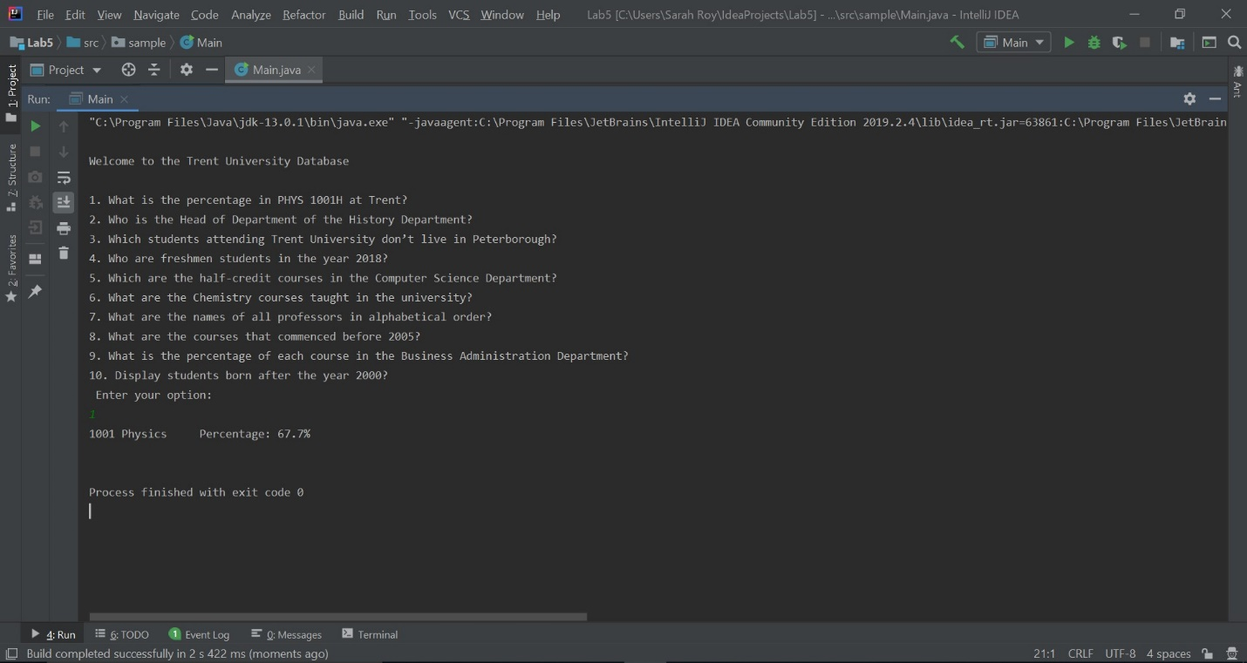

1. **Who is the Head of Department of the History Department?**

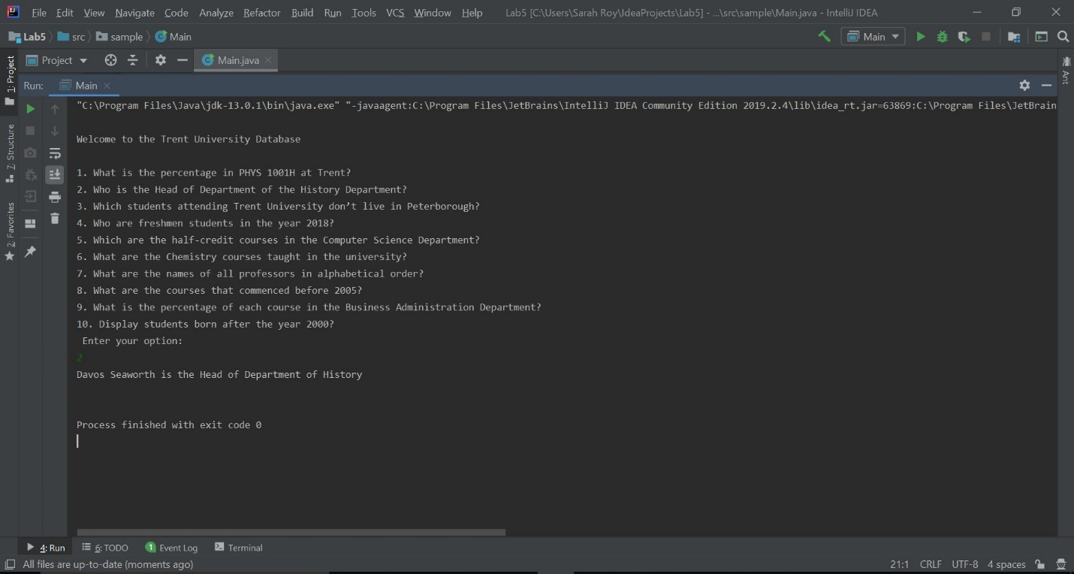

1. **Which students attending Trent University don’t live in Peterborough?**

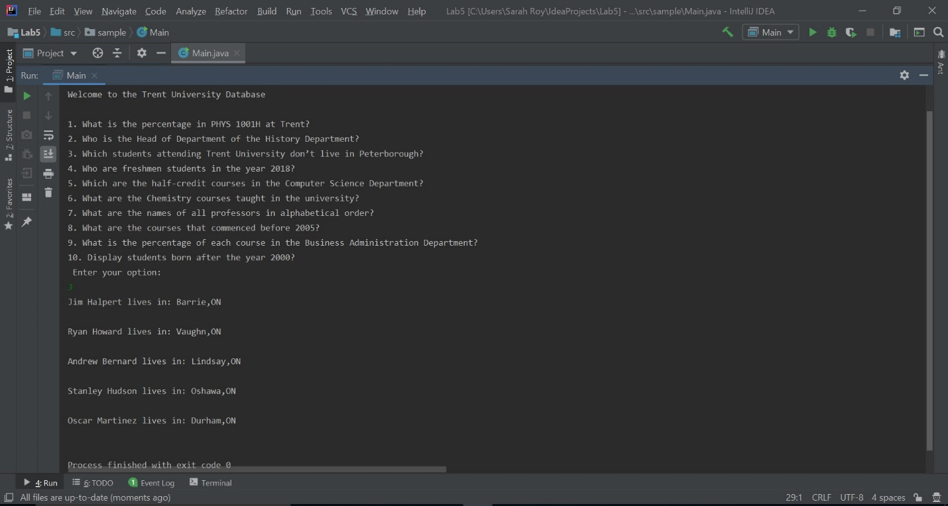

1. **Who were the freshmen students in the year 2018?**

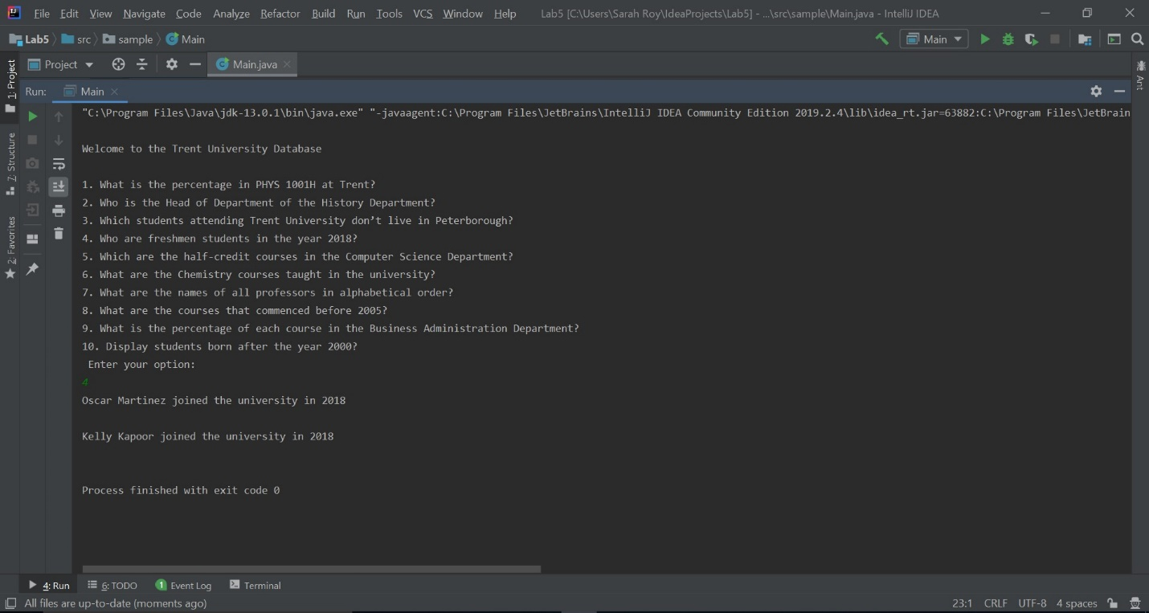

1. **Which are the half-credit courses in the Computer Science Department?**

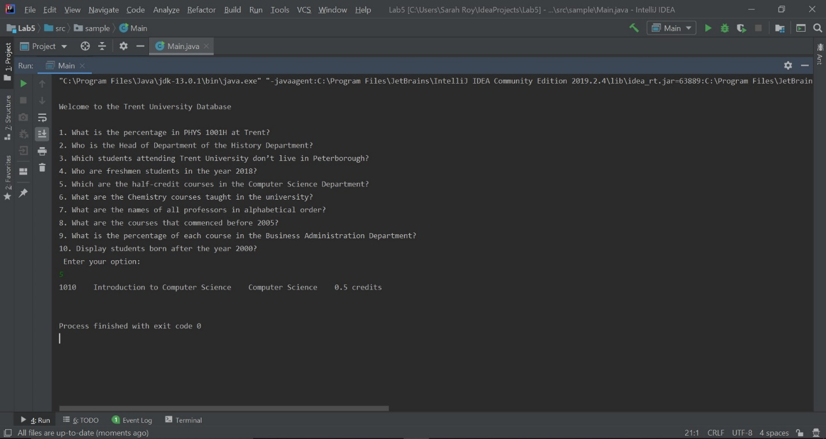

1. **What are the Chemistry courses taught in the university?**

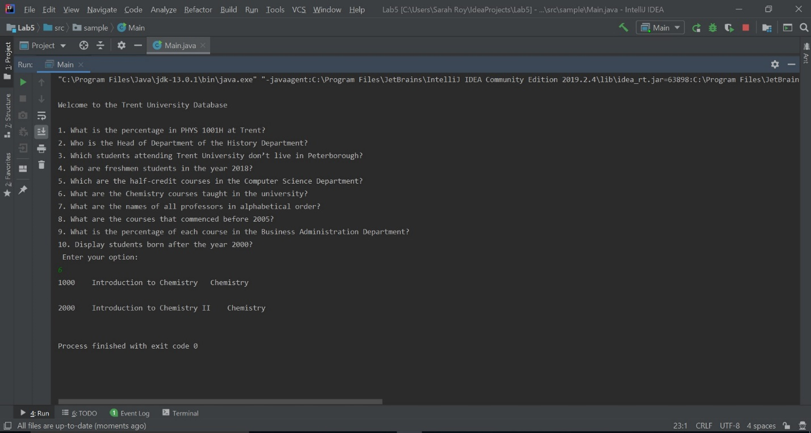

1. **What are the names of all professors in alphabetical order (A-Z)?**

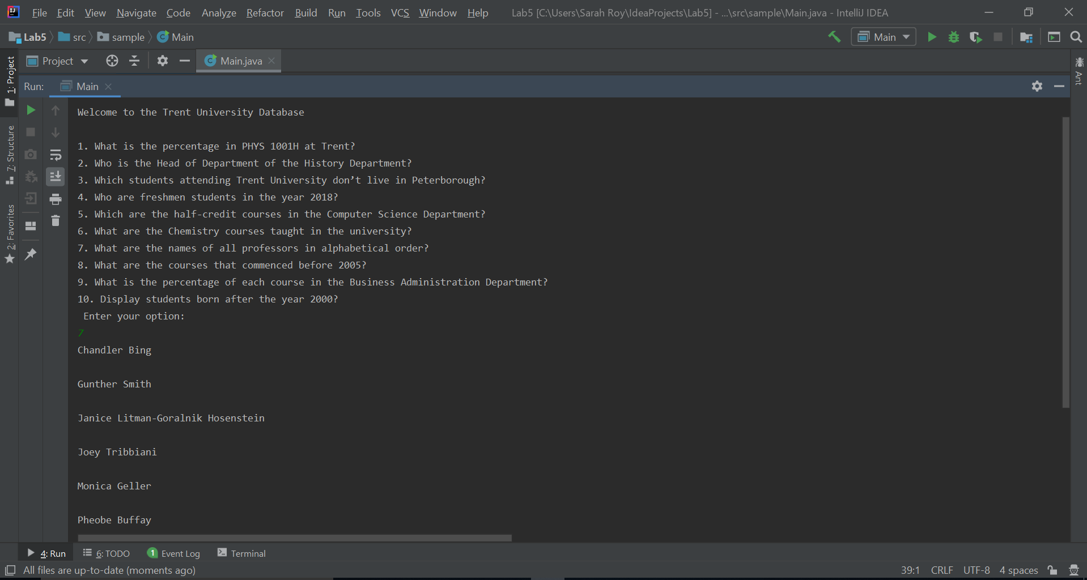

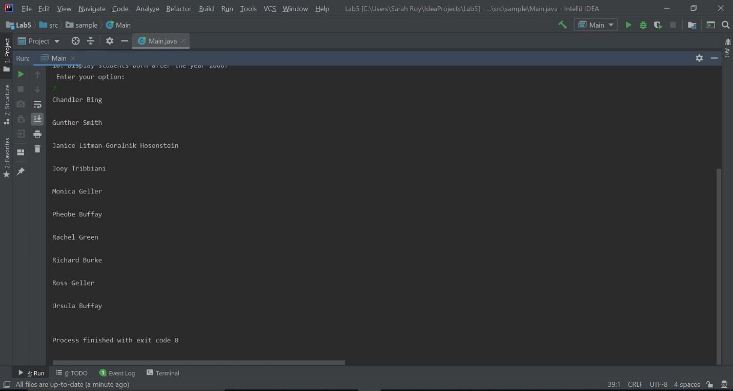

1. **What are the courses that commenced before the year 2005?**

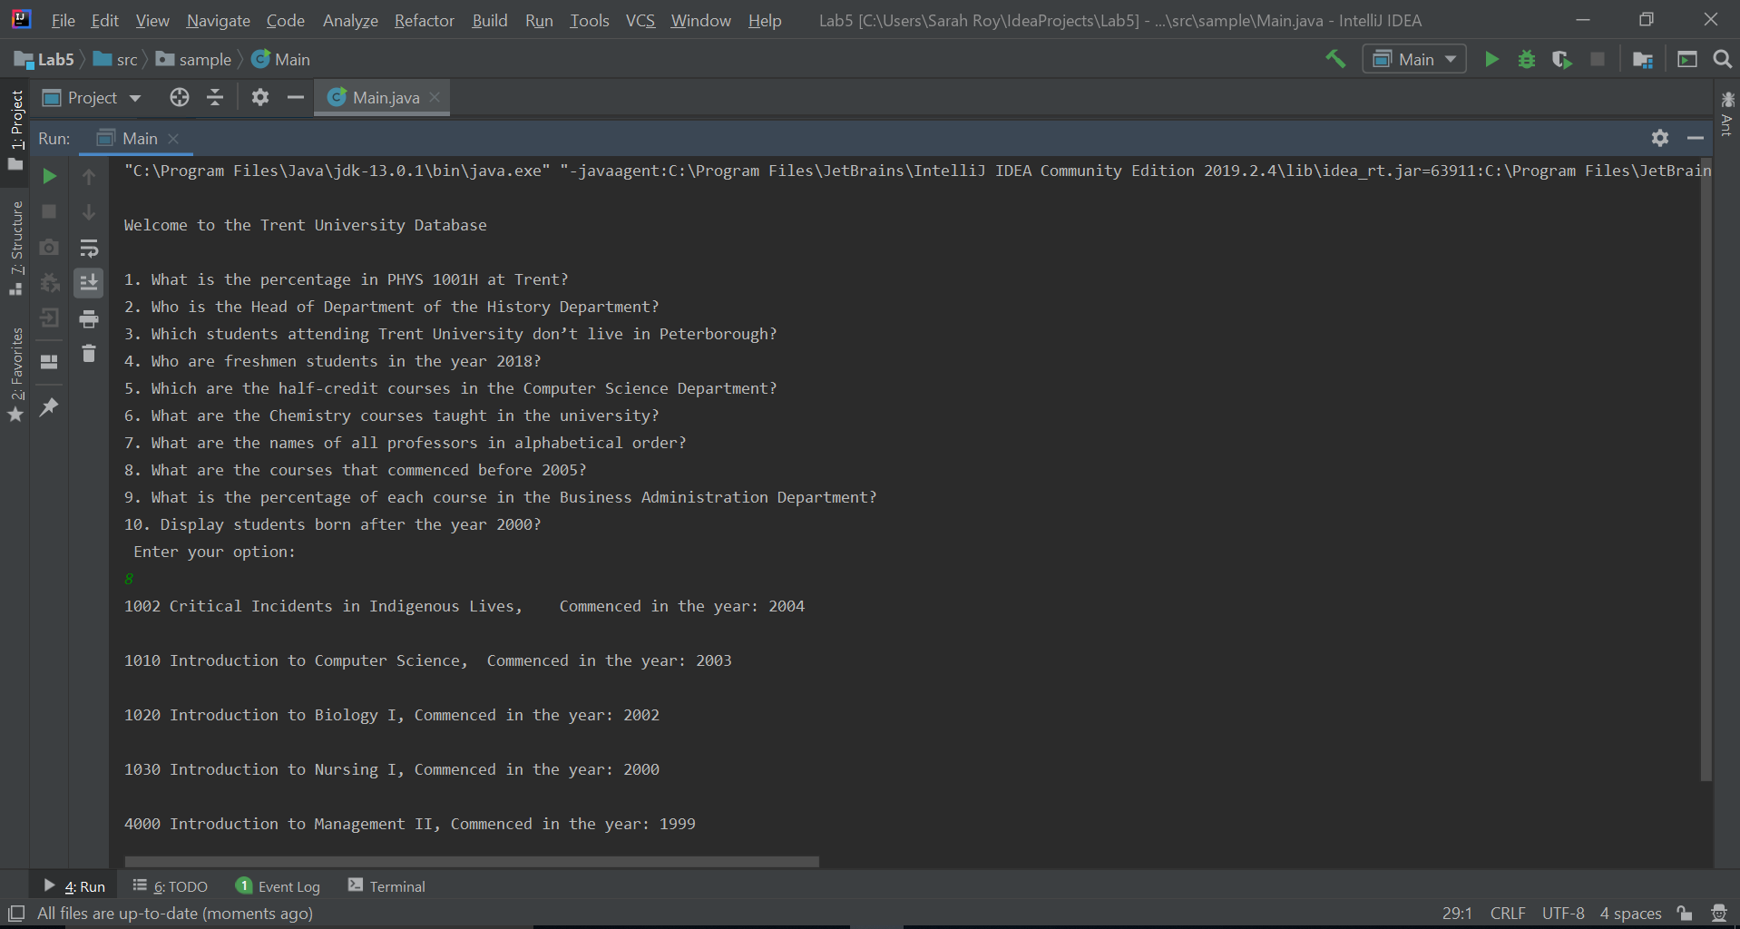

1. **What is the percentage of each course in the Business Administration Department?**

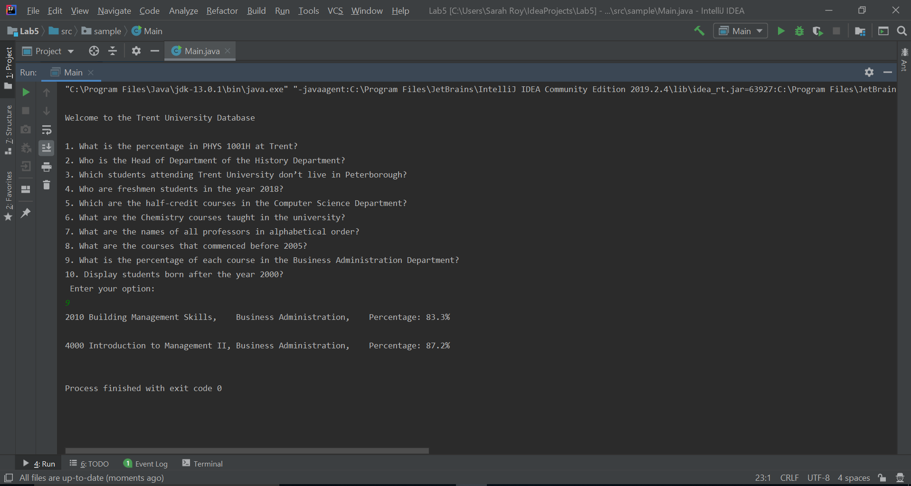

1. **Display students are born after the year 2000?**

